**SECTION A**

1. Why do people wash their hands before eating food?

…………………………………………………………………………………

…………………………………………………………………………………

1. A part from protection of delicate body organs, give one other importance of the human skeleton.

………………………………………………………………………………… …………………………………………………………………………………

1. In which one way can metallic objects be prevented from rusting?

…………………………………………………………………………………

…………………………………………………………………………………

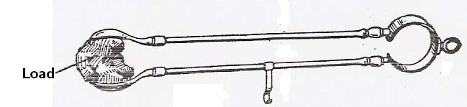***The diagram below shows a simple machine. Use it to answer questions 4 and 5***.

1. Using an arrow show the position of the fulcrum.
2. To which class of lever does the machine above belong?

………………………………………………………………………………… …………………………………………………………………………………

1. By what process does ice change to water?

………………………………………………………………………………… …………………………………………………………………………………

1. If the mass of an object is 45g and its volume is 5cc. find its density.

………………………………………………………………………………… …………………………………………………………………………………

1. Write down one human cause of environmental degradation.

………………………………………………………………………………… …………………………………………………………………………………

1. Mention the vector which spreads germs that cause trachoma.

………………………………………………………………………………… …………………………………………………………………………………

1. Give a reason why coal is called a non renewable resource.

…………………………………………………………………………………

…………………………………………………………………………………

1. Which disorder of the digestive system can be prevented by eating food rich in roughages?

………………………………………………………………………………… …………………………………………………………………………………

1. Write down one difference between a cock a hen.

………………………………………………………………………………… …………………………………………………………………………………

1. Give one advantage of breast feeding to a mother.

………………………………………………………………………………… …………………………………………………………………………………

1. To which group of crops do groundnuts, bean and soya belong?

………………………………………………………………………………… …………………………………………………………………………………

1. 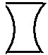Name the type of lens shown below.

………………………………………………………………………………

16. Mention any one mineral salt lost during diarrhoea?

………………………………………………………………………………… …………………………………………………………………………………

1. . A part from hunting, state one other importance of a dog to man.

………………………………………………………………………………… …………………………………………………………………………………

18. What makes milk left on the table for some days go bad?

………………………………………………………………………………… …………………………………………………………………………………

1. Give one reason why a cow is regarded as a ruminant.

………………………………………………………………………………… …………………………………………………………………………………

1. Identify one example of a biological change in the environment.

………………………………………………………………………………… …………………………………………………………………………………

1. Mention one cause of a short circuit. ………………………………………………………………………………… …………………………………………………………………………………
2. Which type of cattle has the body shape shown below?



…………………………………………………………………………………

1. Name one common poultry vice.

………………………………………………………………………………… …………………………………………………………………………………

1. State any one use of fungi to man.

………………………………………………………………………………… …………………………………………………………………………………

1. Name the second stage in the life cycle of a cockroach.

…………………………………………………………………………………

…………………………………………………………………………………

1. Which general name is given to material that does not allow heat or electricity to pass through them?

………………………………………………………………………………… …………………………………………………………………………………

1. Give a reason why a nursery bed should have a shade.

………………………………………………………………………………… …………………………………………………………………………………

1. A part from babies, give one example of a vulnerable group of people.

………………………………………………………………………………… …………………………………………………………………………………

1. Mention any one role played by cilia in the nose of man.

………………………………………………………………………………… …………………………………………………………………………………

1. Write down an activity that helps promote good sanitation in a home.

………………………………………………………………………………… …………………………………………………………………………………

1. State one use of an axe at home.

…………………………………………………………………………………

…………………………………………………………………………………

**The diagram below shows three liquids with different densities. Use it to answer question 32.**

1. 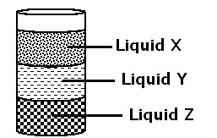Which of the liquids has the lowest density?

………………………………………………………………………………

1. *Suggest one way of preventing the spread of HIV/AIDS.*

………………………………………………………………………………… …………………………………………………………………………………

1. Identify any one viral disease that affects pigs.

………………………………………………………………………………… …………………………………………………………………………………

1. How is a vent pipe useful in a VIP latrine?

………………………………………………………………………………… …………………………………………………………………………………

1. Mention one organism which protects itself by using its pricky hair.

…………………………………………………………………………………

…………………………………………………………………………………

1. Farmers usually keep farm records. Give one reason why you think it is necessary for farmers to keep farm records.

………………………………………………………………………………… …………………………………………………………………………………

1. Name the class of food that helps to repair worn out body tissues.

…………………………………………………………………………………

…………………………………………………………………………………

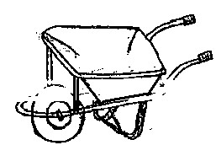**The diagram below shows a simple machine. Use it to answer questions 39 and 40.**

1. Name the machine shown.

………………………………………………………………………………… …………………………………………………………………………………

1. To which class of levers does the machine above belong?

…………………………………………………………………………………

…………………………………………………………………………………

**SECTION B**

1. **Below is a torch. Use it to answer questions which follow.**
2. 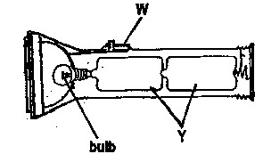Name part marked W.

………………………………………………………………………………… …………………………………………………………………………………

1. Identify the form of energy stored at part Y.

…………………………………………………………

(c)Give two ways the use of electricity helps to conserve the environment.

1. …………………………………………………………………………………..
2. ………………………………………………………………………………….

42. **Study the pulley below and use it to answer questions that follow.**

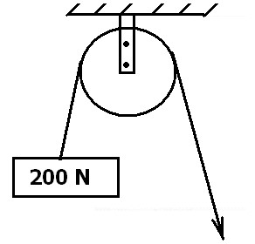(a) Name the type of pulley shown above.

…………………………………………………………………………………

…………………………………………………………………………………

(b) Calculate the value of E.

…………………………………………………………………………………

(c) State the mechanical advantage of the pulley above.

………………………………………………………………………………… …………………………………………………………………………………

(d) Write down any one use of the pulley above at school.

………………………………………………………………………………… …………………………………………………………………………………

43(a) Explain the following terms:

1. Apiculture:

………………………………………………………………………………… …………………………………………………………………………………

1. Swarming:

…………………………………………………………………………………

…………………………………………………………………………………

(b) How are bees useful to?

1. Flowers:

………………………………………………………………………………… …………………………………………………………………………………

1. People:

…………………………………………………………………………………

…………………………………………………………………………………

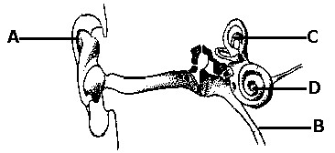44(a) **The diagram below show a human ear. Use it to answer questions that follow.**

(a) Name the parts marked with letters.

(i) B: …………………………………….

ii) D: …………………………………….

(b) State the function of the parts marked with letters.

(i) A: ……………………………………………………………………………… (ii) C: ……………………………………………………………………………….

45. **The diagram below shows a light ray striking a plane mirror.**

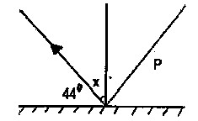(a) Complete the diagram correctly by putting an arrow on

line **P**.

(b) Calculate the value of angle x.

…………………………………………………………………………………

(c) Identify one characteristic of images formed on plane mirrors.

………………………………………………………………………………… …………………………………………………………………………………

46. **The diagram below shows a feeding relationship among living things. Study it carefully and use it to answer questions which follow.**



1. What name is given to the relationship above?

………………………………………………………………………………… …………………………………………………………………………………

1. Which organism in the list above is referred to as:
2. A primary consumer

…………………………………………………………………………………

…………………………………………………………………………………

1. A decomposer

………………………………………………………………………………… …………………………………………………………………………………

(c) A part from food, give one other way animals depend on each other.

…………………………………………………………………………………

…………………………………………………………………………………

47(a) Which component of blood is responsible for;

1. Clotting of blood

…………………………………………………………………………………

…………………………………………………………………………………

1. Transporting oxygen around the body

………………………………………………………………………………… …………………………………………………………………………………

1. Defending the body against disease causing germs.

………………………………………………………………………………… …………………………………………………………………………………

(b) State one possible cause of anaemia.

………………………………………………………………………………… …………………………………………………………………………………

48(a) Write down two requirements of a pregnant woman.

(i) ………………………………………………………………………………… (ii) ………………………………………………………………………………….

1. Identify one problem a P.7 girl is likely to face if she becomes pregnant.

………………………………………………………………………………… …………………………………………………………………………………

1. Give one sign of pregnancy in woman.

………………………………………………………………………………… …………………………………………………………………………………

49(a) Suggest any two reasons why people drink alcohol.

(i) ………………………………………………………………………………… (ii) ………………………………………………………………………………….

1. A part from drinking, state one other use of alcohol to people.

…………………………………………………………………………………

…………………………………………………………………………………

1. Name one body organ that is damaged due to excessive alcohol consumption. ………………………………………………………………………………… …………………………………………………………………………………
2. **Complete the table below correctly**.

|  |  |
| --- | --- |
| **Animal** | **Breathing organs** |
| (a) | Moist skin |
| cockroach | (b) |
| (c) | Lung books |
| fish | (d) |

1. **The diagram below shows a female reproductive organ.**

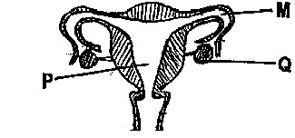(a) Name the parts marked **P** and **Q**

(i). **P**………………………………….

(ii) **Q**…………………………………

(b) What process takes place in part **M**?

………………………………………………………………………………… …………………………………………………………………………………

(c) Identify the fungal disease that affects the organ above.

………………………………………………………………………………… …………………………………………………………………………………

52(a) Give two reasons why farmers spray their crops in the garden.

(i) ……………………………………………………………………………….. (ii) …………………………………………………………………………………

(b) A part from spraying, give two other ways of caring for crops in the garden.

1. …………………………………………………………………………………
2. …………………………………………………………………………………

53(a) Study the tooth and wheels below and use them to answer the questions that follow.

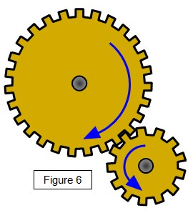

**T**

* 1. To which group of simple machines do the tooth and wheels belong?

………………………………………………………………………………… …………………………………………………………………………………

* 1. Use arrows to show the direction of the revolution.
  2. If wheel Q has 45 teeth and it is thrice as big as wheel T, How many revolutions does wheel T make when Q turns once?

…………………………………………………………………………………

* 1. Identify the force that can affect the proper rotation of the above wheels.

…………………………………………………………………………………

…………………………………………………………………………………

54. **The diagram below shows a human kidney. Use it to answer the questions that follow.**

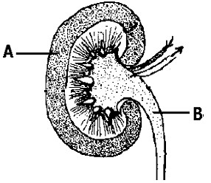(a) Name the part marked

………………………………………………………………………… (b)What process takes place in part marked **A**?

………………………………………………………………………………… …………………………………………………………………………………

(c) Name any diseases that affects the system shown in the diagram above. ………………………………………………………………………………… …………………………………………………………………………………

1. Write down one way of caring for the kidney and the urinary system.

………………………………………………………………………………… …………………………………………………………………………………

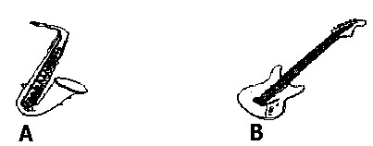55(a) **The diagram below shows two types of instruments A and B.**

(a) Name the type of instruments A and B.

(i) A: ……………………………………………

(ii) B………………….…………………………...

1. What does the diagram below illustrate in

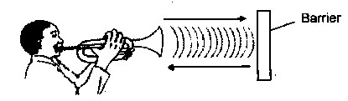 relation the transmission of sound energy?

………………………………………………………………………………… …………………………………………………………………………………

1. Give at least one way of reproducing stored music in Uganda today.

…………………………………………………………………………………

…………………………………………………………………………………